**Setup : YOLO**

**Step 1:** download yolo4 image : git clone https://github.com/AlexeyAB/darknet.git

download cuda:

CUDA and cuDNN to accelerate YOLOv4 inference using the DNN(deep neural network) module.

**Step 2:**

downloading CUDA:

https://developer.nvidia.com/cuda-downloads

select linux/windows

use the below command in linux to find the architechture:

uname -m

distribution > select ubuntu

for version, use command hostnamectl

Installer type: though deb is usually used, it needs more steps, hence use runfile(local)

but do sudo apt-get update

sudo apt-get upgrade

**Step 3:**

sudo add-apt-repository ppa:graphics-drivers/ppa

and sudo apt update

for cuda12 we need minimum 450 version of nvidia at till 525 is compatible.

use command: apt-get install nvidia-driver 450

Use can uncheck the option while downloading cuda tool kit.

**Step 4:**

Let us make all installation files in on directory.

go to home:

mkdir installers

cd installers

here run command to download cuda:

eg url: https://developer.nvidia.com/cuda-downloads?target_os=Linux&target_arch=x86_64&Distribution=Ubuntu&target_version=22.04&target_type=runfile_local

wget https://developer.download.nvidia.com/compute/cuda/12.0.0/local_installers/cuda_12.0.0_525.60.13_linux.run

--------------------------------------------------------------------

for object detection bounding boxes, we can use, coco json, tensor flow object detection csv, etc

**Step 5:**

Use command: hostnamectl

to find the architechture and ubuntu version

select appropriate architechture, ubuntu version and also the run file local instead of the deb file

wget https://developer.download.nvidia.com/compute/cuda/12.0.0/local_installers/cuda_12.0.0_525.60.13_linux.runsudo sh cuda_12.0.0_525.60.13_linux.run

sudo sh cuda_12.0.0_525.60.13_linux.run

**Step 6:**

After running the second command, new menu will be prompted, select install.

Possible errors at this stage:

check the file, it should be mostly because nvidia overwrite won’t be allowed.

Re-run sudo sh cuda_12.0.0_525.60.13_linux.run

deselect nvidia , and install the rest (others should be installed, cuda shouldn’t be deselected).

**Step 7:**

After a while:

A summary will be shown as below

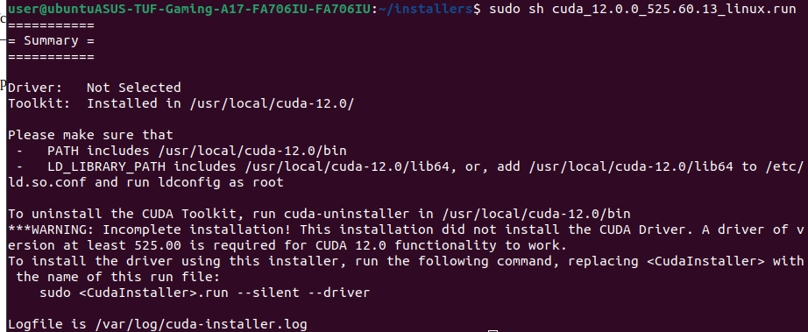

Add the below in the .bashrc file(available in home directory):

export PATH="/usr/local/cuda-12.0/bin"

export LD_LIBRARY_PATH="/usr/local/cuda-12.0/lib64"

save and to reflect the changes use the command:

source ~/.bashrc

**Step 8:**

Now do:

sudo reboot

**Step 9:**

check installation with below command: (checks nvidia cuda compiler driver)

nvcc -V

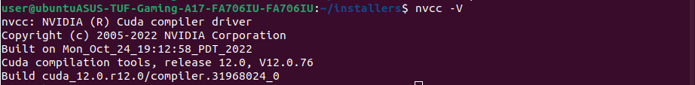

**Step 10:**

Also use nvidia-smi

There is a command-line utility tool, Nvidia-smi (also NVSMI) which **monitors and manages NVIDIA GPUs**. It is installed along with the CUDA toolkit and provides you with meaningful insights.